

Rome, April 12, 2026

To the national Franciscan Families
around the world

Subject: Proposal for the World Week of the Poor 2026, on the occasion of the 800th anniversary of the Transitus of St. Francis

Dear brothers and sisters,
On the occasion of the 800th anniversary of the Transitus of St. Francis of Assisi, we wish to propose an initiative focusing on the poor and all forms of poverty.
We have drawn inspiration from the “Mission to the Poor”, which is being organized in Rome from November 9 to 15, 2026, coinciding with World Day of the Poor.

Following in the footsteps of Francis – who, having arrived in Rome as a pilgrim to the tomb of the Apostle Peter, gave his clothes to the most needy, spending the entire day among the poor with joyful spirit – we wish to bear witness that it is possible, even today, to give voice to the reality of the poor, to listen to them rather than simply speak about them, and to carry out together a prophetic gesture that tells the Church and society that the preferential option for the poor is not an optional choice, but belongs to the very essence of our Franciscan charism and of being Christians.

Here are the six key points of the initiative, which can be used as inspiration if you decide to organize the “Week of the Poor”:

1. Moving towards poverty
The goal is to address both visible and hidden forms of poverty by raising awareness among public opinion and institutions. This is not about organizing events, but about physically going out to the places where poverty dwells, day and night, in systematic and continuous manner throughout the entire week.

2. Listening: let the poor speak
The key attitude is to listen: not to “speak about the poor”, but to put the poor themselves first, allowing them to tell their own stories – their lives, their dreams, and their struggles. This listening will become a valuable legacy to be handed over, at the end of the mission, to the government of one’s own country and to the Church as the fruit of the experience lived.

3. The educational dimension
During the week, it would be important to offer educational sessions for participants. For example, topics such as the following could be explored more deeply: Francis and the leper as a model for encountering the poor; the intelligence of the heart and the poor heart; the dialogue between Franciscan presence and the city; an analysis of the causes of poverty; and, finally, how to transform indignation into hope in order to create a prophetic sign. Roundtable discussions with the public opinion and institutions, study sessions, and meetings in schools can also be planned, so as to raise awareness among the younger generations regarding the issue of poverty.

4. Prayer as the heart of the mission
The spiritual dimension is fundamental. A fixed prayer space could be set up, where the missionary group would gather daily for prayer; and perhaps also a mobile prayer presence in different locations, to combine a tangible focus on people with prayer, in accordance with the Gospel in marginalized areas.

5. Collaboration with other entities: a mission approach
We would like to highlight one aspect of this proposal in particular: its openness to collaboration. The missionary group should be formed of religious and lay Franciscans, but also of every man and woman of good will. The approach we suggest is not to operate alone as Franciscan Family: the Week would aim to enhance and promote collaboration with other ecclesial (Catholic and non-Catholic) and civil entities present in the area. This openness to collaboration would be a very Franciscan sign: maybe only we can dare to do so much!

6. The prophetic sign at the end of the mission
The mission concludes on November 15, World Day of the Poor. It would be great to find a prophetic public gesture – different for each context and arising from the listening experienced during the week – to give back to the Church and society what has been gained from the encounter with the poor.

Therefore, it is with great joy that we invite you to join us, as the Franciscan Family, in celebrating a “Week of the Poor” between November 9 and 15, 2026: an act of fidelity to the Gospel, to the charism of Francis, to Pope Francis’ call to stand by those whom the Lord himself has pointed out to us as his beloved, and to what Pope Leo reminds us: “The poor are not a distraction for the Church, but our beloved brothers and sisters, for by their lives, their words and their wisdom, they put us in contact with the truth of the Gospel.”

Those national Franciscan Families that will have welcomed and implemented the proposed initiative (in one or more cities or remote villages) are kindly asked to communicate this (via email to conspresofs_02@ciofs.org) so that we may provide Pope Leo with a global overview. Having shown great enthusiasm for the initiative in Rome, he will be even happier to hear of its worldwide dissemination.

We greet you fraternally, in the name of St. Francis!


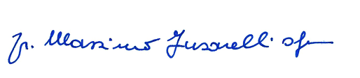

Br. Massimo Fusarelli OFM Br. Carlos Alberto Trovarelli OFM Conv
Minister General Minister General
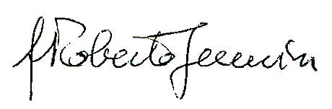
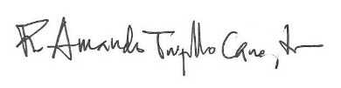

Br. Roberto Genuin OFM Cap Br. Amando Trujillo Cano TOR
Minister General Minister General
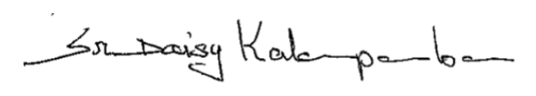


Tibor Kauser OFS sr. Daisy Kalamparamban
Minister General IFC-TOR President

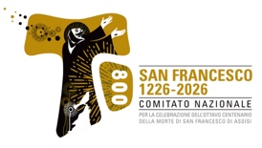
With the contribution of

Message of the Holy Father Pope Leo XIV for the 9th World Day of the Poor, 16th of November 2025.

