Franciscan Family Conference
Fr. Michael Anthony Perry  Ministro Generale OFM  Curia Generalizia  Via S. Maria Mediatrice, 25  00165 Roma  tel.: +39 - 0668.49.19  Fax: +39 - 0663.80.292  Fr. Marco Tasca  Ministro Generale OFMConv.  Curia Generalizia  Piazza Ss. Apostoli, 51  00187 Roma  tel.: +39 - 06699.571  fax: +39 - 06699.57321  Fr. Mauro Jöhri  Ministro Generale OFMCap.  Curia Generalizia  Via Piemonte, 70  00187 Roma  tel.: +39 - 06.42011.710  fax: +39 - 064620.1210  Fr. Nicholas Polichnowski  Ministro Generale TOR  Curia Generalizia  Via dei Fori Imperiali, 1  00186 Roma  tel.: +39 - 066920441  fax: +39 - 06678.4970  Tibor Kauser  Ministro Generale OFS  Béla Kiraly utja 98  2081 PILISCSABA  UNGHERIA  Sr. Deborah Lockwood  Ministra Generale O.S.F.  Via Cassia, 870  00189 Roma  tel.: +39-0633258201  fax: +39-0633252865  Presidente di turno CIF-TOR | The Portiuncula Indulgence and the Jubilee Year of Mercy  Two important events are marked during 2016: the anniversary of the date traditionally associated with the granting of the Portiuncula Indulgence, which was inspired by St. Francis’ wish that "everyone be brought to heaven", and the celebration of the Jubilee of Mercy, inspired by the Pope who bears St. Francis’ name.  We can leave to historians the debate regarding when exactly the Portiuncula Indulgence was granted; our concern here is the opportunity provided by this coincidence of dates to explore the rich theme of mercy and forgiveness in the context of our Franciscan spiritual tradition.  The word Misericordia is very dear to St. Francis, who in his writings frequently uses it in two ways; referring both to God's mercy towards us, and our showing mercy to our brothers and sisters. This is reminiscent of the Gospel phrase that the Pope has suggested as the motto of the Jubilee Year: "Be merciful as your Father is merciful" (Lk 6:36). Our merciful relationships with others are closely linked to the mercy that God shows us: God’s love is the limitless spring from which we can draw the mercy that we then communicate to our neighbor. And as we know, we can love only to the extent that we are aware of being loved by the Divine Source of all good.  What we generally say about love can also be said about forgiveness, which is a specific form of mercy. The parable that Jesus tells in response to Peter's question "how many times must I forgive?" condemns the behavior of the servant who does not forgive his co-worker’s small debt, when previously the master had forgiven him a huge debt. Once again, the reason for forgiving others is that we ourselves have been forgiven by God - as we pray in the Our Father, "forgive us our trespasses as we forgive those who trespass against us." That "as" does not so much indicate an equivalence, it indicates the motive behind our forgiveness of others: from the certainty that God has forgiven me comes the need to forgive "as" the Father forgives. This is another way of saying that we should be merciful "as" the Father is merciful.  Given the truth of this, a sure way for us to become increasingly merciful is to grow in the awareness that we ourselves are loved by God. Here again we make the association between the gift received from God and the gift offered to the brothers and sisters, something which is characteristic of the Franciscan spiritual experience. To the extent that
we, like Francis, discover that God "is the good, all good, the highest good, and he alone is good", so the need to respond to the good that we have received gains strength in us, with the consequence that we pass on the goodness of which we are capable.
And since in order to become more aware of God's love for me it is necessary to make some time for reflection, we become aware that we have been invited to cultivate a spirit of prayer and devotion, to unite contemplation and action. This is essential if we wish to rediscover the true source of our commitment and love of neighbor, to recover the strength and energy needed to spend our lives in the service of our brothers and sisters, and to generate a culture of peace and reconciliation, which are the fruits of the contemplation of love.
When he asked the Pope for an extraordinary indulgence for the little church of the Portiuncula, Francis found a new means of celebrating Gods’ abundant forgiveness and mercy towards us. We can take up and deepen the beautiful definition of indulgence which Pope Francis has given in Misericordiae vultus, when he describes it as “indulgence on the part of the Father who, through the Bride of Christ, his Church, reaches the pardoned sinner and frees him from every residue left by the consequences of sin, enabling him to act with charity, to grow in love rather than to fall back into sin.” (MV 22). Whenever we receive this amazing indulgence of the Father through the Church, we too experience an outpouring of mercy, and this allows us to become more capable of compassion and reconciliation in real life situations.
We can see wonderful examples of this creative ability to promote peace and reconciliation in the life of Francis. The episode at the end of his life, when he reconciled the Civil Authority (Podestà) and the Bishop of Assisi, comes to mind. He did this by singing his Canticle of Brother Sun, with the addition of a verse on forgiveness. An early biographer writes at the beginning of this story that Francis told his companions: "It is a great shame for you, servants of God, that the bishop and the podestà hate one another in this way, and that there is no one intervening for peace and harmony between them."(Assisi Compilation, 84). Francis does not assume that this is an issue of no concern to him; he has a sense of shame because no one has intervened in order to restore peace. I wonder whether we too feel some shame because no one intervenes in the conflicts of our time? How much responsibility do we feel, as Francis did, to bring about peace and reconciliation? To do this above all in our own fraternities, when there are divisions, but also in regard to the political, religious, economic, and social conflicts of our time?
An engaged and pro-active commitment such as this arises from the deep contemplation of God’s love for me. Precisely because I feel personally touched by the Father’s indulgence, a certain strength, courage, and splendid "foolishness" is evoked in me. This leads me to get involved, but only in the manner of a poor person who is in love with God – to intervene with a song, rather than with solemn speech, much less with force. St. Francis, with his intelligent simplicity, did not attempt to call the Bishop and the Podestà to a meeting to try to resolve their differences. Francis knew very well that this is not his way: instead he gathered them to listen to a song, because it was only by directing their vision to a higher plane, towards the beauty of God - and doing so on the wings of song - that these two men locked in conflict would be able to recognize the highest reasons for living in peace. In today's world we Franciscans are probably not often called to address and solve the complex problems of the world by offering technical solutions, or by being involved in difficult issues, which are often beyond us. Instead, we are called to find ways to foster reconciliation and peace by touching people’s hearts with the witness of minority, simplicity, beauty and song. By living as brothers and sisters in sincerity and truth, we witness to what is essential; and the people of today, just like the Podestà and the Bishop of Assisi, can thus recognize how worthwhile it is to live in peace, seeing problems in their proper perspective, and choosing the path of forgiveness.
In speaking of indulgence and mercy, we first looked at the Father's indulgence and mercy towards us, and then moved on to speak about being positively engaged in the conflictual realities of today's world. But we could also have done the reverse: beginning from forgiveness and reconciliation with our brothers and sisters, and subsequently speaking about the mercy of God, as Francis does in his Testament. What matters most is that the two aspects must not be disconnected, since in the Gospels Jesus teaches that the first of the commandments deals simultaneously with the love of God and of neighbor, two components that can never be separated.
May this centenary help us to experience a “healthy shame” because of the lack of those strongly committed to working for peace and harmony in the conflictual realities in which we live. May it help us grow in our creative abilities to find new ways to sing a song that the men and women of our time can relate to. May our lives be a living song of praise to God, the source all love, and thus be a real inspiration for peacebuilding and reconciliation.

Rome, July 23, 2016, feast of St. Brigid, Patroness of Europe


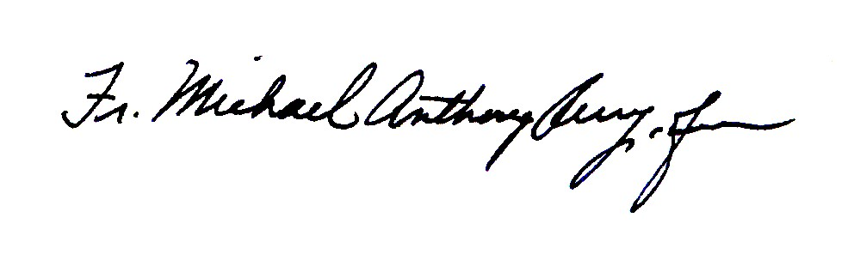
_________________________________ ___________________________
Fr. Michael Anthony Perry,OFM Sr. Deborah Lockwood, OSF
Minister General Minister General



____________________________ ____________________________
Fr. Mauro Jöhri, OFMCap Fr. Nicholas Polichnowski, TOR
Minister General Minister General
President FFC

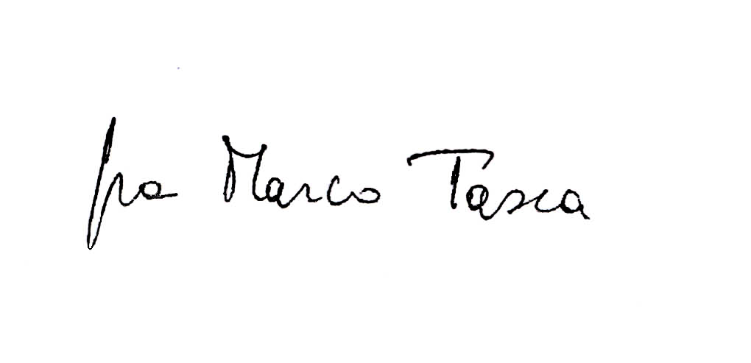


____________________________ ____________________________
Fr. Marco Tasca, OFMConv Tibor Kauser, OFS
Minister General Minister General

