Prot. N. 00992/16 Rome, November 29 2016
Feast of All Saints of the Franciscan Order

To all the Brothers of the Order
Dear Brothers:

May the Lord give you His peace!

The holiness of so many Franciscan brothers and sisters throughout history testifies that, as Francis intuitively understood, to live according to the form of the holy Gospel is still a beautiful and liberating journey for all those who want to be authentic in living their vocation.
A few days ago at the General Curia we concluded the annual meeting of the IV International Formation Council. Its main aim was to produce the resource materials that will help us reflect on how to draft the Ratio Formationis Ordinis, which is to be presented to the next General Chapter.
We would like to arrive at a text that is substantial, concise and topical, offering practical guidelines for formation to ensure unity and plurality in the living of our Capuchin Franciscan charism. But that is not enough. Unless the brothers play an active part, the text, whatever its quality, will be more difficult to put into practice.
Precisely on this point of how to achieve participation, I would like to remind all major superiors that it is important to give full value to the role of the one who is in charge of formation in each circumscription of the Order. His task is to assist you, the major superiors, and the international formation councillors, in the job of motivating, accompanying and checking the reflection process, making sure that it is participative and fraternal.
The first questionnaire, sent out on February 2 this year, was well received. We are happy with the replies received and, as far as possible, we try to take account of the directions that the results indicate. But in addition to the high number of replies, what pleases us most is to see that brothers from nearly every circumscription, of all ages and differing sensitivities, responded to the questionnaire. Anyone who has not yet done so may still reply until the end of the year. We must continue as we have begun.
We are now sending you the Draft of chapter 1 of the Ratio, which you can use for a day of recollection in this Advent season which has just begun, or during Christmastide. You will find more detailed instructions in the introduction.
What is the purpose of reading and reflecting on this chapter? First of all, it is so that each brother may compare his own experiences and images of Saint Francis with those that appear in the proposed text. Secondly, to be able to share as a fraternity not just our impressions of the text, but also the impact and importance of the charismatic figure of Saint Francis in our own lives. Finally, the aim is to see if, in the opinion of the fraternity, some dimension of the figure of Saint Francis is not reflected with sufficient emphasis or clarity, or if some important aspects are either missing or over-emphasised in the text. Please feel free to make whatever comments you feel are appropriate.
Once your fraternity retreat and meeting have been held, you should send a summary of your observations – drafted as concisely as possible - to the director of formation of your circumscription; he in turn will summarise the replies and send them to the International Formation Councillor, who will then send to the General Curia a synthesis of the replies received from the Conference.
May I also take this opportunity to remind you about the meetings that have been planned at continental level, to jointly prepare the three Appendices that will accompany the text of the Ratio:
- Affective and psycho-sexual maturity
- Ratio Studiorum (Contents of the Study Programme)
- A cultural tool by which to translate the Ratio Formationis into the formation plans of each circumscription.
The dates and places of the meetings will be as follows:
America: Guatemala City (Guatemala): July 10 - 14 2017
- Europe: Prague (Czech Republic): August 28 to September 1, 2017
- Africa: Addis Ababa (Ethiopia): February 5 – 9, 2018
- Asia: Jakarta (Indonesia): February 26 to March 2, 2018.
Who should attend these meetings ?
- The General Minister and the General Councillors of the area
- The General Secretariat for Formation
- The International Formation Councillors of the area
- The director of formation in each circumscription
Saint Francis invites us to open our eyes of faith to discover the hidden presence of Jesus in the smallest details of everyday life. We are in the Advent season: the most important Guest in our lives is about to arrive. Let us prepare for His coming as Mary did, by setting out for the hill-country, full of eagerness to serve. May she, Our Lady of Hope, accompany us at every stage and fill us with hope, us as we prepare the Ratio.

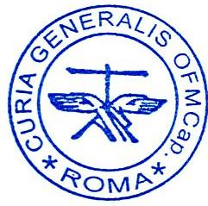
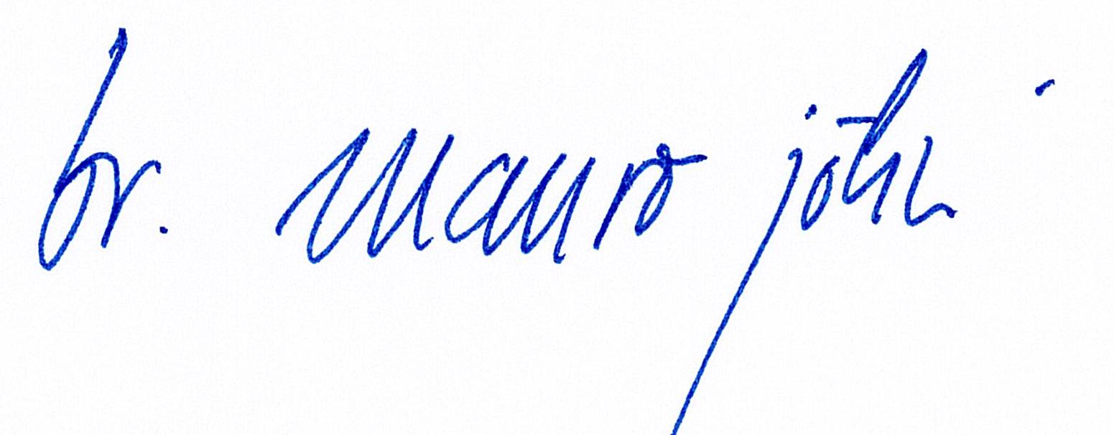
Fraternally,

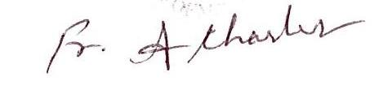
Br. Mauro Jöhri
General Minister OFM Cap.
Br. Charles Alphonse OFM Cap.
General Secretary for Formation

